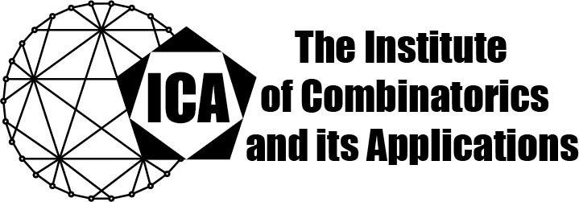

For immediate release Contact: Sarah Holliday
April 20, 2020 Secretary of the ICA Email: sarah.holliday@gmail.com url: the-ica.org

Dr Jeroen Schillewaert awarded the 2019 Hall Medal of the ICA

Hall Medals recognize extensive quality research with substantial international impact by Fellows of the ICA in mid-career.

Dr Schillewaert earned his PhD in 2009 from the University of Ghent under Drs J Thas and L Storme. He currently holds the rank of Senior Lecturer at University of Auckland, in New Zealand, in the Department of Mathematics.

Jeroen Schillewaert has made significant contributions to a broad range of topics in combinatorics and finite geometry, combining techniques from extremal and probabilistic combinatorics, linear algebra, and group theory. He is a world expert on buildings, the combinatorial and geometric structures introduced by Jacques Tits. His work has applications in coding theory and cryptography.

Dr. Schillewaert has published over thirty papers in prestigious generalist journals and in the best specialist journals. He has been awarded several prestigious fellowships, including an Oberwolfach Leibniz Fellowship, a Marie Curie Fellowship, and an Alexander von Humboldt Fellowship. He is frequently invited to speak at leading conferences, and to visit research programmes and institutes. Dr. Schillewaert’s nominators describe his work as “very clever”, “remarkable and beautiful”, “highly substantial”, and “extremely subtle”.

The Institute of Combinatorics and its Applications is an international scholarly society that was founded in 1990 by Ralph Stanton; the ICA was established for the purpose of promoting the development of combinatorics and of encouraging publications and conferences in combinatorics and its applications.

