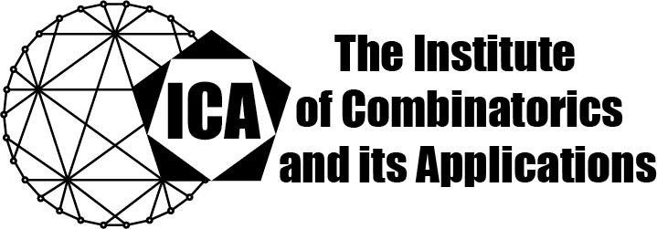

For immediate release Contact: Sarah Holliday
April 20, 2020 Secretary of the ICA Email: sarah.holliday@gmail.com url: the-ica.org

Dr Koen Thas awarded the 2019 Hall Medal of the ICA

Hall Medals recognize extensive quality research with substantial international impact by Fellows of the ICA in mid-career.

Dr Thas earned his PhD in 2002 from the University of Ghent under Hendrik van Malgedhem while acting as a Research Assistant of The Agency for Innovation and Entrepreneurship in Flanders, Belgium. Subsequently, he held a position as a Postdoctoral Research Fellow of the fund for Scientific Research at FWO in Flanders, Belgium. As of 2010, he is a Professor at Ghent University in the Department of Mathematics.

Koen Thas has made significant contributions in the areas of finite geometry and absolute geometry, and has addressed important problems in mathematical physics and quantum information theory using geometric and group-theoretic methods. He has solved a number of fundamental open problems by eminent researchers. His classification work in the theory of generalized quadrangles has been described as “very interesting” and “groundbreaking”, with “remarkable results, thought of as out of reach for a long time”. In his work linking algebraic geometry over F₁ and combinatorics, he was one of the first in almost forty years to contribute new substantial results to infinite Singer theory.

Dr. Thas was awarded an ICA Kirkman Medal in 2006, and the Triennial Prize of the Flemish Science Foundation for Exact Sciences in 2009. He is the sole author of over fifty papers and two books, and a co-author of many more, and has given numerous invited talks at conferences around the world.

The Institute of Combinatorics and its Applications is an international scholarly society that was founded in 1990 by Ralph Stanton; the ICA was established for the purpose of promoting the development of combinatorics and of encouraging publications and conferences in combinatorics and its applications.

