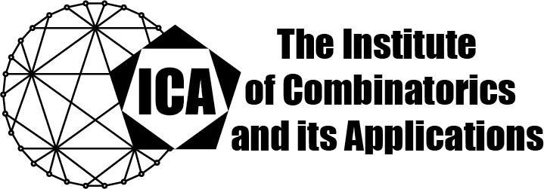

For immediate release Contact: Sarah Holliday
April 20, 2020 Secretary of the ICA Email: sarah.holliday@gmail.com url: the-ica.org

Dr Tao Zhang awarded the 2019 Kirkman Medal of the ICA
Kirkman Medals recognize excellent research by Fellows or Associate Fellows of the ICA early in their research career, as evidenced by an excellent body of published research.

Dr. Zhang earned his PhD in 2017 at Zhejiang University under Professor Gennian Ge. Since 2017, he has served as Associate Professor at Guangzhou University.

Dr. Tao Zhang has made deep contributions to lattice tilings and their applications, algebraic coding theory, and design theory. His notable research achievements include a significant advance on the Golomb-Welch conjecture on lattice tilings, and the construction of new classes of quantum error-correcting codes with large minimum distance.

Dr. Zhang’s research has resulted in more than twenty published papers in top-ranked discrete mathematics and electrical engineering journals. He has given ten conference and workshop talks, including a plenary address and an invited talk. The excellence of his doctoral dissertation was recognized with awards from Zhejiang University and Zhejiang Province. His nominators describe him as “a very original, passionate, and hard-working researcher”, and attest that “the depth and breadth of Tao Zhang’s research are very impressive”.

The Institute of Combinatorics and its Applications is an international scholarly society that was founded in 1990 by Ralph Stanton; the ICA was established for the purpose of promoting the development of combinatorics and of encouraging publications and conferences in combinatorics and its applications

