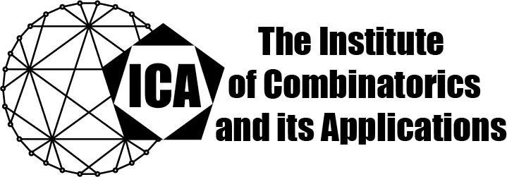

For immediate release Contact: Sarah Holliday
June 4, 2021 Secretary of the ICA Email: sarah.holliday@gmail.com url: the-ica.org

Dr Jie Ma awarded the 2020 Hall Medal of the ICA

Hall Medals recognize extensive quality research with substantial international impact by Fellows of the ICA in mid-career.

Dr. Ma received the B.S. degree from the School of Mathematical Sciences, USTC, and subsequently obtained his Ph.D. degree in 2011 from the School of Mathematics, Georgia Institute of Technology, under the supervision of Prof. Xingxing Yu. He was a Hedrick Assistant Professor at the Department of Mathematics, UCLA, and a Postdoctoral Associate at the Department of Mathematical Sciences, Carnegie Mellon University. Dr. Ma is now a professor at the School of Mathematical Sciences, University of Science and Technology of China (USTC).

Jie Ma has made outstanding contributions in the fields of extremal and probabilistic combinatorics, and structural graph theory. He obtained several important results in the study of hypergraph Turan numbers, and proved several conjectures on the distribution of cycle lengths in graphs. He solved, or asymptotically solved, several open problems by Bollobas and Scott on judicial partitions of graphs and hypergraphs, which is a “very strong, impressive record". Using “sophisticated arguments and novel tools", he has made breakthroughs on several other difficult, longstanding problems of structural and extremal flavour.

Dr. Ma has published over thirty papers in the most prestigious combinatorial journals. He is a frequent speaker at national and international conferences, and a member of recognized editorial boards.

The Institute of Combinatorics and its Applications is an international scholarly society that was founded in 1990 by Ralph Stanton; the ICA was established for the purpose of promoting the development of combinatorics and of encouraging publications and conferences in combinatorics and its applications.

