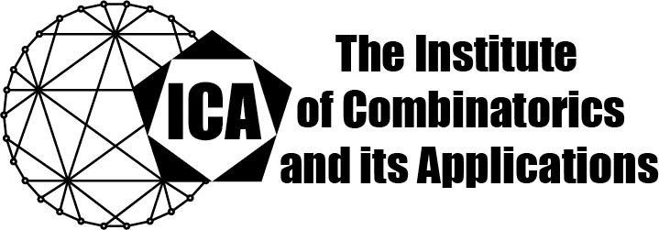

For immediate release Contact: Sarah Holliday
June 4, 2021 Secretary of the ICA
Email: sarah.holliday@gmail.com url: the-ica.org

Dr Chong Shangguan awarded the 2020 Kirkman Medal of the ICA
Kirkman Medals recognize excellent research by Fellows or Associate Fellows of the ICA early in their research career, as evidenced by an excellent body of published research.

Dr. Shangguan earned his PhD in 2017 at Zhejiang University under Professor Gennian Ge. From Aug 2017 to July 2020, he was a postdoc researcher at Department of Electrical Engineering-Systems, Tel Aviv University, hosted by Dr. Itzhak Tamo. Since September 2020, he has been a faculty member of the Research Center for Mathematics and Interdisciplinary Sciences as Shandong University.

Chong Shangguan has made deep contributions to extremal combinatorics and combinatorial coding theory. His notable research achievements include an original and elegant proof regarding the combinatorial list-decodability of Reed-Solomon codes, significant progress on two well-known and difficult conjectures on the Turan number of sparse hypergraphs, and the resolution of several conjectures and open problems on perfect hash and separating hash families.

Dr. Shangguan's research has resulted in 16 published papers, most of which appeared in the very best journals or conference proceedings in the fields of combinatorics, coding theory, and theoretical computer science. A striking feature of his research is the broad range from theory to applications, where tools from extremal combinatorics, additive combinatorics, probabilistic
combinatorics, and the polynomial method are involved.

The Institute of Combinatorics and its Applications is an international scholarly society that was founded in 1990 by Ralph Stanton; the ICA was established for the purpose of promoting the development of combinatorics and of encouraging publications and conferences in combinatorics and its applications

