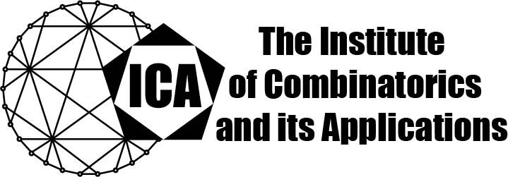

For immediate release Contact: Sarah Holliday
March 9, 2023 Secretary of the ICA
Email: sarah.holliday@gmail.com
url: the-ica.org

Dr. Jan De Beule awarded the 2022 Hall Medal of the ICA

Hall Medals recognize extensive quality research with substantial international impact by Fellows of the ICA in mid-career.

Jan De Beule obtained a PhD in Mathematics at Ghent University, Belgium in 2004. He had positions as postdoctoral researcher at Ghent University, at the Research Foundation Flanders in Belgium, and at the Vrije Universiteit Brussel (VUB), Belgium. Since 2020, he is a professor at the Vrije Universiteit Brussel (VUB). His research field concerns finite projective spaces, their substructures, their applications in coding theory, and computer algebra.

He is a co-author of over 40 publications in international mathematics journals, one chapter in a book, 3 conference proceedings and was co-editor for 3 edited works. He is co-editor of the book: Current research topics in Galois geometry (NOVA Sci. Publ.), which was specifically written to stimulate research on Galois Geometry. The topics on which he has contributed vary from blocking sets in finite projective spaces and in finite classical polar spaces, partial ovoids and partial spreads in finite classical polar spaces, Cameron-Liebler sets in finite projective spaces, minihypers in finite projective spaces and linear codes meeting the Griesmer bound, to arcs and linear MDS codes, and degree 2 Boolean functions on Grassmann graphs. His most important results include: (1) the non-existence of maximal partial ovoids of size $q^{2}-1$ in the generalized quadrangle $Q\left(4,q\right), q=p^{h}$, p an odd prime, h > 1, (2) the determination of the size of the largest partial spreads in the Hermitian variety $H(5, q^{2})$, (3) his work on the MDS conjecture with S. Ball and on other related problems on linear MDS codes, and (4) a new infinite family of Cameron-Liebler line classes in PG(3,q), q ≡ 5 (mod 12) or q ≡ 9 (mod 12), with parameter $x=(q^{2}-1)$. The methods he applied to obtain these results include geometrical and polynomial techniques.

The Institute of Combinatorics and its Applications is an international scholarly society that was founded in 1990 by Ralph Stanton; the ICA was established for the purpose of promoting the development of combinatorics and of encouraging publications and conferences in combinatorics and its applications.

