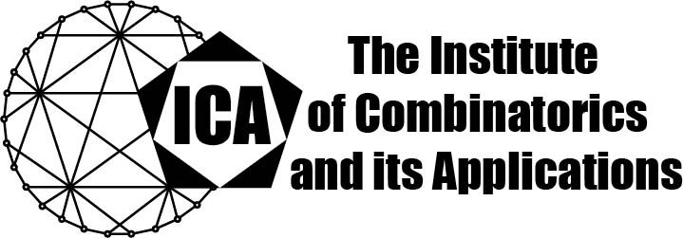

For immediate release Contact: Sarah Holliday
March 9, 2023 Secretary of the ICA
Email: sarah.holliday@gmail.com
url: the-ica.org

Dr. Melissa Huggan awarded the 2022 Kirkman Medal of the ICA

Kirkman Medals recognize excellent research by Fellows or Associate Fellows of the ICA early in their research career, as evidenced by an excellent body of published research.
Melissa Huggan is an intelligent, broadly talented, internationally well-connected, young mathematician. She is a leading light in combinatorial game theory and has forged and strengthened connections between it and economic game theory and other branches of combinatorics including graph theory and design theory. She has published her research since her undergraduate degree in mathematics and has twenty published articles in refereed journals. In her PhD research she began developing a theory of combinatorial games that include economic properties: simultaneous play and scoring. At the same time, she made significant contributions to standard CGT including tests for determining when a game is a number, complexity analyses and reduced canonical form. In her post-doctoral research, Dr. Huggan included Pursuit-Evasion games in her research program. Throughout her research she has developed a particular expertise of the mathematics of games and combinatorial designs, solving tic-tac-toe on triple systems, solving in special cases and determining the complexity of an independent set game on designs and graphs and extending pursuit-evasion games to designs. Additionally, she is a leader in her profession, distinguishing herself in organizing conferences, mathematical outreach and teaching excellence.
The Institute of Combinatorics and its Applications is an international scholarly society that was founded in 1990 by Ralph Stanton; the ICA was established for the purpose of promoting the development of combinatorics and of encouraging publications and conferences in combinatorics and its applications.

