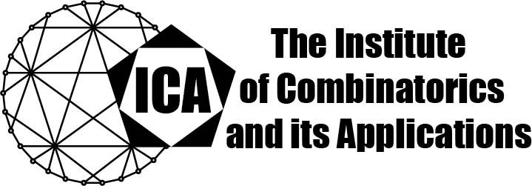

For immediate release Contact: Sarah Holliday
March 9, 2023 Secretary of the ICA
Email: sarah.holliday@gmail.com
url: the-ica.org

Dr. Pablo Spiga awarded the 2022 Hall Medal of the ICA

Hall Medals recognize extensive quality research with substantial international impact by Fellows of the ICA in mid-career.
Pablo Spiga is Professor of Mathematics at the University of Milano-Bicocca, and is one of the most innovative and productive combinatorial mathematicians of his generation. Pablo works across permutation group theory and graph symmetry with applications impinging on number theory, model theory, finite geometry and semigroup theory. Since graduating with his PhD from Queen Mary University of London in 2004, he has published an astonishing 125 journal articles with two research monographs in the pipeline.
Pablo Spiga is well known for his work on graph symmetry, for example, his proof of the Babai-Godsil conjecture, and the Potocnik-Spiga-Verret (PSV) conjecture that local semiprimitivity is the precise property to guarantee restrictions on the vertex stabiliser for vertex-transitive graphs. Pablo’s work is breath-takingly innovative, yielding unexpected results. For example, apart from natural exceptions, every element of every finite primitive permutation group has at least one regular cycle. Many of Pablo’s results were motivated from other areas: his work on irreducible linear groups led to his astonishing result that no primitive permutation group has as many as three subdegrees with each pair coprime. His classification of finite primitive permutation groups containing elements with few cycles was directly applied to bound the normal covering numbers of symmetric groups, and his proof of Cherlin's conjecture for primitive binary groups concerns the complexity of a relational structure in model theory.
The Institute of Combinatorics and its Applications is an international scholarly society that was founded in 1990 by Ralph Stanton; the ICA was established for the purpose of promoting the development of combinatorics and of encouraging publications and conferences in combinatorics and its applications.

