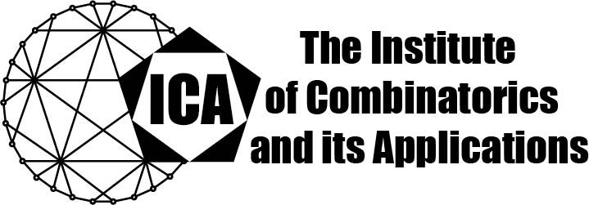

For immediate release Contact: Sarah Holliday
March 9, 2023 Secretary of the ICA
Email: sarah.holliday@gmail.com
url: the-ica.org

Dr. Ziqing Xiang awarded the 2022 Kirkman Medal of the ICA

Kirkman Medals recognize excellent research by Fellows or Associate Fellows of the ICA early in their research career, as evidenced by an excellent body of published research.
Ziqing Xiang has made significant contributions in several areas of combinatorics, namely, design theory, algebraic combinatorics, and graph theory. He also has done work in representation theory. Combining algebraic and number theoretic techniques with computer explorations, he has solved numerous longstanding open problems in design theory and algebraic combinatorics. For example, he solved Delsarte and Seidel’s conjecture on a Fisher type lower bound for the size of relative t-wise balanced combinatorial designs. By considering the combinatorial properties of nontrivial tight 8-designs and developing a method to solve the related Diophantine equation, he succeeded in proving that there are no integral points on the curve associated with a nontrivial tight 8-design, hence proving the nonexistence of nontrivial tight 8-designs. Ziqing and his coauthors generalized Seymour and Zaslavsky’s result on the existence of t-designs on a path-connected topological space equipped with good measure to the existence of t-designs on an algebraically path-connected space equipped with good measure. So far, he has published 9 papers in high quality general mathematics journals as well as in top quality specialized journals in combinatorics. He has frequently given seminar talks, and invited talks at national and international conferences.

The Institute of Combinatorics and its Applications is an international scholarly society that was founded in 1990 by Ralph Stanton; the ICA was established for the purpose of promoting the development of combinatorics and of encouraging publications and conferences in combinatorics and its applications.

