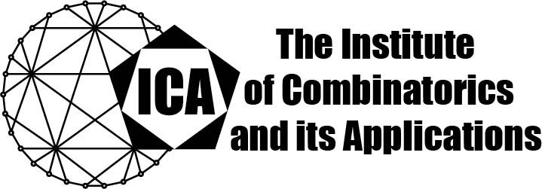

For immediate release Contact: Sarah Heuss, Secretary of the ICA
June 4, 2024 Email: sarah.heuss@gmail.com
url: the-ica.org

Dr. Jan Goedgebeur awarded the 2023 Hall Medal of the ICA

Hall Medals recognize extensive quality research with substantial international impact by Fellows of the ICA in mid-career.

Jan Goedgebeur is at the forefront of designing and deploying novel algorithms and computational techniques, which are not only interesting on their own but also contribute significantly to progress in combinatorics and extremal graph theory, in particular to problems related to graph coloring, generation of combinatorial structures, hamiltonicity, Ramsey-type problems, optimization problems and chemical graph theory. His work consistently leads to new algorithms which refine prior computational techniques to generate objects such as cubic graphs, snarks, fullerenes and triangle-free Ramsey graphs. These algorithms are often more efficient than previous algorithms. One of his main contributions is his work jointly with others on Ramsey numbers of type R(3,G) for graphs G on 10 vertices, in particular for obtaining the improved upper bound R(3,K₁₀) < 43.

Jan Goedgebeur received his PhD from University of Ghent in 2013, and is now faculty at KU Leuven Campus Kulak. He has so far 49 journal publications, and Google Scholar lists 988 citations. Many of his publications are in top journals such as the Journal of Graph Theory and the Journal of Combinatorial Theory, Series B. His passion has created a vibrant community of scholars inspired by his accomplishments and expertise.

The Institute of Combinatorics and its Applications is an international scholarly society that was founded in 1990 by Ralph Stanton; the ICA was established for the purpose of promoting the development of combinatorics and of encouraging publications and conferences in combinatorics and its applications.

