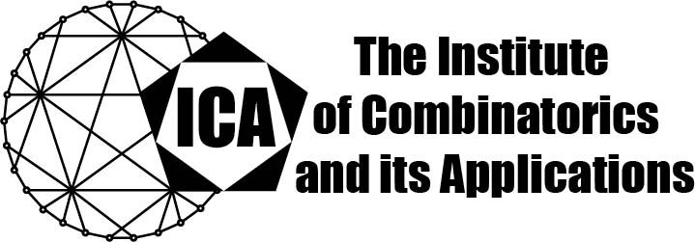

For immediate release Contact: Sarah Heuss, Secretary of the ICA
June 4, 2024 Email: sarah.heuss@gmail.com
url: the-ica.org

Dr. Yifan Jing awarded the 2023 Kirkman Medal of the ICA

Kirkman Medals recognize excellent research by Fellows or Associate Fellows of the ICA early in their research career, as evidenced by an excellent body of published research.
Yifan Jing earned his PhD from the University of Illinois Urbana-Champaign in 2021. Subsequently, he was a Postdoctoral Research Associate at the Mathematical Institute at the University of Oxford and a Junior Research Fellow in Wolfson College at Oxford. This Fall, he will be an Assistant Professor in the Department of Mathematics at Ohio State University.

Yifan Jing is a highly accomplished young mathematician specializing in arithmetic
combinatorics, extremal combinatorics, and graph theory. His notable contributions
include significant advancements in resolving major conjectures and publishing extensively in prestigious journals such as Geometric and Functional Analysis, the Transactions of the American Mathematical Society, and the Journal of Combinatorial Theory, Series B. Yifan's achievements encompass proving the nonabelian Brunn-Minkowski inequality and obtaining an inverse theorem for Kemperman's inequality. He has also made remarkable progress in understanding the structure of symmetric polynomial nonexpanders and achieving state-of-the-art results for Stein's square function in three-dimensional Euclidean space. His work in topological graph theory includes a polynomial-time approximation scheme for computing the genus of dense graphs, a breakthrough result that was accepted at IEEE Annual Symposium on Foundations of Computer Science (FOCS).
The Institute of Combinatorics and its Applications is an international scholarly society that was founded in 1990 by Ralph Stanton; the ICA was established for the purpose of promoting the development of combinatorics and of encouraging publications and conferences in combinatorics and its applications.

