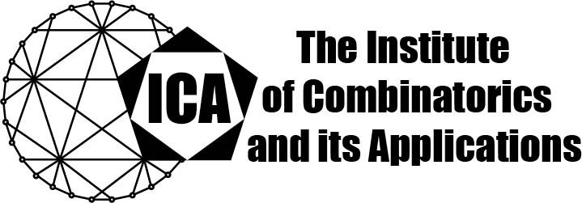

For immediate release Contact: Sarah Heuss, Secretary of the ICA
June 4, 2024 Email: sarah.heuss@gmail.com
url: the-ica.org

Dr. Sam Mattheus awarded the 2023 Kirkman Medal of the ICA

Kirkman Medals recognize excellent research by Fellows or Associate Fellows of the ICA early in their research career, as evidenced by an excellent body of published research.
Sam Mattheus obtained in 2016 the degree of Master in Mathematics, with Summa Cum Laude, at Ghent University. Sam Mattheus obtained in 2022 the Degree of Doctor in Mathematics at the Free University of Brussels (VUB). Since 2022, he is a junior postdoctoral fellow of the Flemish Research Foundation at the VUB. During the academic year 2022-2023, he was a visiting scholar at the University of California, San Diego, thanks to a BAEF-Hoover Foundation Fellowship and a Fulbright Visiting Fellowship. Although he only recently received his PhD, he has already 14 accepted publications in international journals.

The research of Sam Mattheus is spread over several domains. He is very successful in combining ideas from finite geometry in relation to graph theoretical problems, in particular to problems in extremal graph theory. His research has recently culminated into the solution of a problem in Ramsey theory that remained unsolved for more than 40 years. The Ramsey number r(s,t) is the minimum number of vertices a graph must have so that the graph either contains a clique of size s or a coclique of size t. The asymptotic behaviour of r(4,t) posed a major problem for the research community. Sam Mattheus, in collaboration with Jacques Verstraëte, succeeded in proving that r(4,t)=Ω(t³ / log⁴ t) as t goes to infinity. The high significance of this result is proven by its acceptance in the Annals of Mathematics. Jointly with other researchers, he is currently extending some of the developed ideas to other Ramsey numbers.
The Institute of Combinatorics and its Applications is an international scholarly society that was founded in 1990 by Ralph Stanton; the ICA was established for the purpose of promoting the development of combinatorics and of encouraging publications and conferences in combinatorics and its applications.

