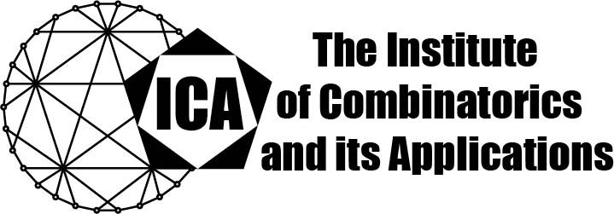

For immediate release Contact: Sarah Heuss, Secretary of the ICA
June 4, 2024 Email: sarah.heuss@gmail.com
url: the-ica.org

Dr. Jennifer Seberry awarded the 2023 Euler Medal of the ICA

Euler Medals recognize distinguished lifetime career contributions to combinatorial research by Fellows of the ICA, including those who remain active in research.
Jennifer Roma Seberry (Wallis) has made distinguished contributions to Discrete Mathematics over her sixty-year career. She is world renowned for her new discoveries on Hadamard matrices, orthogonal designs, weighing matrices, Bhaskar Rao designs and statistical designs. She has applied bent functions and S-box design to the design of secure cryptoalgorithms and strong hashing algorithms for secure and reliable information transfer in networks and telecommunications. Her studies of Hadamard matrices and orthogonal designs are applied in CDMA technologies. Her outstanding contributions to research and education in cryptologic research led to her election as Fellow of the International Association for Cryptologic Research, and among her other honours is award of the Combinatorial Mathematics Society of Australia's gold medal. She has been a co-founder of the Australasian Combinatorics Conferences, and the AUSCRYTP/ASIACRYPT international conference series.

Google Scholar currently reports 10052 citations of her work, along with an h-index of 43 and an i10-index of 208.

Jennifer Seberry is a remarkable researcher, educator and mentor, a pioneer carving out an impressive legacy and lighting the way for those who follow. Her kindness and enthusiasm are hallmarks of her outstanding personality.

The Institute of Combinatorics and its Applications is an international scholarly society that was founded in 1990 by Ralph Stanton; the ICA was established for the purpose of promoting the development of combinatorics and of encouraging publications and conferences in combinatorics and its applications.

